1.

a.

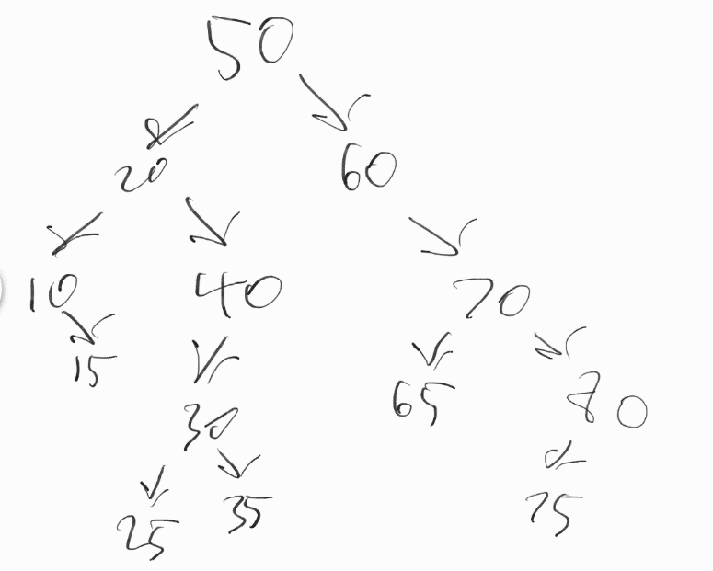

b.

Pre-order   
50 20 10 15 40 30 25 35 60 70 65 80 75  
In order   
10 15 20 25 30 35 40 50 60 65 70 75 80  
Post-order  
15 10 25 35 30 40 20 65 75 80 70 60 50

c.

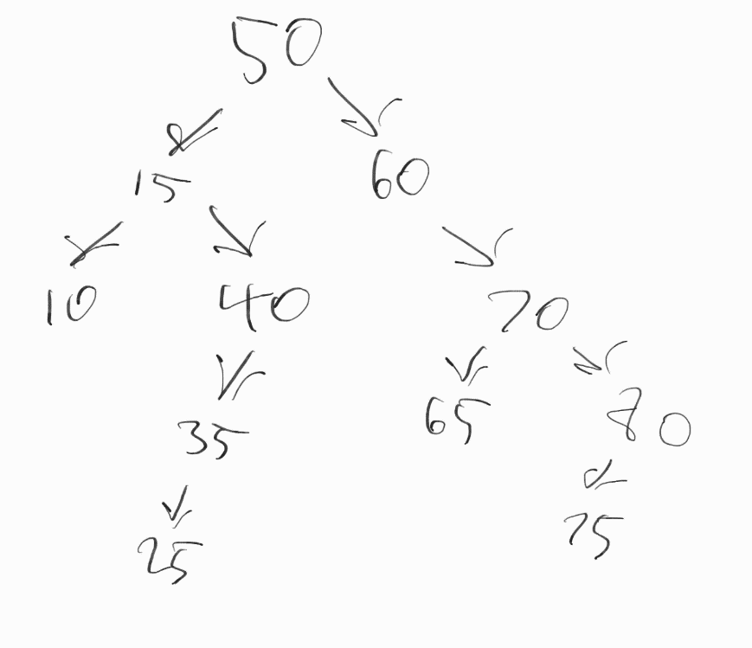

2.

struct BTNode {

BTNode\* parent;

int data;

BTNode\* left;

BTNode\* right;

};

insert(Node\* pNode, int thisData){

if the pNode is nullptr, create a new node;

let creating a new node set all contained pointers to be nullptr by default.

if thisData is less than pNode->data,

call insert(pNode->left) and set pNode's left child's parent to be pNode

otherwise, call insert(pNode->right) and set pNode's right child's parent to be pNode.

}

//if duplicates aren't allowed, then check if thisData > pNode->data instead of just doing otherwise

3.

a.

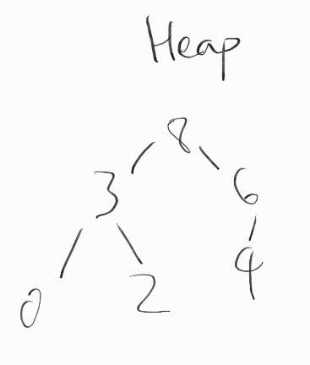

b. [8, 3, 6, 0, 2, 4]

c. [6, 3, 4, 0, 2]

4.

a. O(C + S)

b. O(log(C) + S)

c. O(log(C) + log(S))

d. O(log(S))

e. O(1)

f. O(log(C) + S)

g. O(S\*log(S))

h. O(C\*log(S))